**Virtual Reality** (with in it, 3D game design)

What is it?

3D game design, is a form of online game creation and 3D Virtual reality shows a view of a place in a 3-dimensional real-life perspective. The objects that appear and scenery is 3 dimensional, showing height, width and length. It is used to create a more ‘real life’ feel to a game or experience and enhance aesthetics. 3D and well-designed graphics improve the engagement and enjoyment of the game making it feel real like that is happening is true and that the characters are alive. The primary reason for 3D games and Virtual Reality is enjoyment and giving you experiences otherwise impossible.

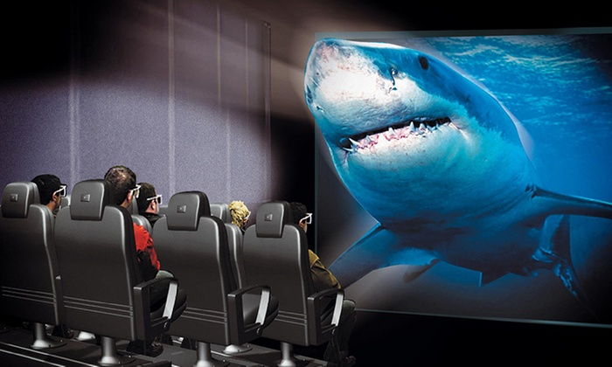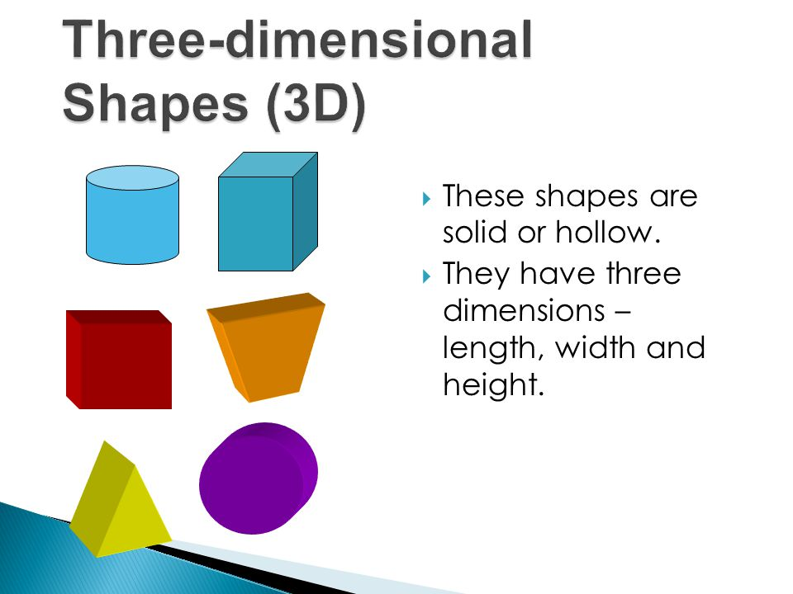

How is it used?

Obviously, it’s main use is for enjoyment and playing, however Virtual Reality can have broader real-life applications and purposes. Virtual reality is being used to train employees and train medical students. This creates great opportunities in education, giving you a ‘real’ experience of what it will be like and what to do. Medical students can preform practise surgery’s, gaining the skills and experience without physically hurting anyone in the case of their mistakes. VR can be used on the other side of this situation as well, a study has been conducted that when visiting the dentists, patients are much less likely to experience pain when they were wearing a VR headset and anxiety levels were lower. Imagine the calming alternative of a beach or forest in comparison to a ‘intimidating’ white room and sharp implements. This can be furthered, VR could help treat patients with PTSD, help autistic children practise social skills and even allow paraplegics to regain feeling and slight movement. Its extraordinary the possibilities that we have only began to explore. In the future Virtual Reality will become more and more apart of our lives, not just for games and entertainment but important parts of life and the medical industry.

 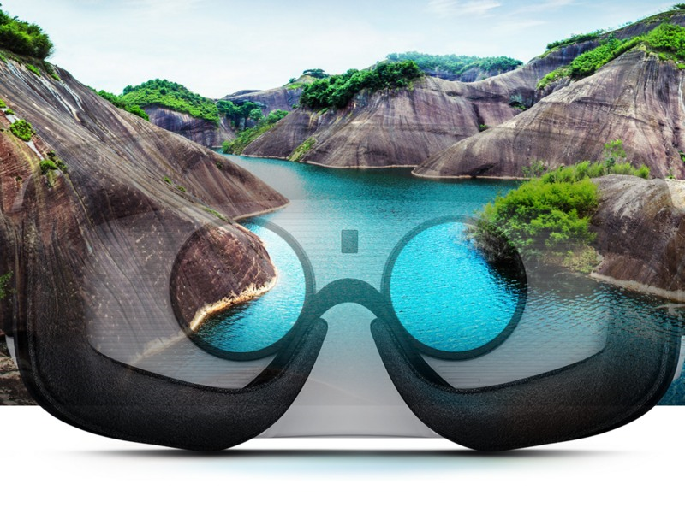

Benefits of Virtual Reality

As I have discussed prior (in section Uses), there are many ways we use Virtual Reality for important things in the work force and with medication and phycology. One of the key benefits is saving money and resources, and increased safety within training of the work force. It costs a lot of money to train a workforce, most of this money is because of the Practical Elements and the resources need for these. Damage can also come to the trainee, resources or bystander, if mistakes are made. This makes it conventionally better to use Virtual Reality to save these costs and make sure no one will get hurt, while giving the trainee the skills and practice they need to be successful in the work force. This mostly applies to medical students or military training, but VR can be used across the board for education. This brings us to another benefit, engagement in learning. Young students while using VR can experience field trips in other countries and even go back in time to bring history to life. This brings excitement and eagerness to learn. VR, as I discussed in its uses, can be very effective in helping people who suffer from Anxiety, phobias or PTSD. The benefit is that VR can transport you anywhere in the world- or time and space for that matter- getting you away from a trapped feeling or stressful situation. Another benefit with this ‘travel’ is a cheaper way to experience things, whether it’s watching your favourite movie, live broadcasting or a ‘trip’ to the Eiffel tower. This saves money, again, but also lets as do things we might not otherwise be able to do, from travel to snorkelling, it lets us overcome our restraints.

Negatives/ Fallbacks of Virtual Reality

We can get lost in a world of Virtual Reality to overcome our problems or experience somethings, but it becomes dangerous when we get too lost in a world of fantasy. My main concern with VR is the social addictions. What happens when you begin to prefer the Virtual World to the real one? Addictions to gaming and Netflix (for example) would suggest we will soon face similar problems in virtual reality. We don’t yet know how this will play out for society, but it won’t be good. Low resolution, file concentrations and initial cost are surface level issues compared to what the future will hold. This is relatively unknown when we look at the long-term effects on individuals and society. *The problem, however, is that we don’t know its long-term effects on either the body or the mind. We are in a wait-and-see situation. That’s frightening, but we are also in a similar situation with smartphones, so what can you do?1* We do however know some of the short-term effects of using VR for extended periods of time. You can lose your special awareness, feel dizzy and disoriented and in extreme cases experience seizers or nausea. Another issue is that you can’t see the world that’s actually around you. You can’t see any wires, trip hazards or other people- making it unsafe and collision prone. The main thing we need to worry about is that its unknow. It doesn’t sound to scary, but we are playing with things with unknown consequences- imagine it as before cigarettes were known to cause lung cancer. As a society we could be sucked in and stuck in a world of constant Virtual Reality, were we know longer know what’s real or virtual! Alternatively, we may all suffer unknown consequences on top of the short-term ones listed.

Software used

There seems to be a range of Software available. A quick google search shows Virtual Reality headsets available from $40 to >$1000, from brands such as Kogan, Noon and HTC. These seem pretty simple but it becomes more complicated when you look at the developing Virtual Reality Software. Here are a few engines used to develop and create VR;

* Unreal engine
* Unity 3D
* Cryengine
* Lumberyard

In order to make 3D games or VR you also need to create and model your landscapes and characters. The following are a few of the available options for modelling software;

* 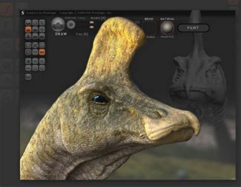Sketchup Make
* Wings 3d
* Equinox 3d
* Daz studio
* 3D crafter
* Blender
* Sculptris

To just watch/ experience VR you simply need a smartphone, a headset and a Virtual Reality app. To create VR you would need to look at more of the prior software, to create and produce VR.

Limitations at school

The two main limitations will be resources and my own knowledge. Firstly, VR software and headsets can cost a lot depending how advanced they are. Secondly, my knowledge in this is extremely limited (to this assignment alone) and the limitations of one teacher for a whole class will mean I must work it out myself. To over come these issues, I can use the free software and either find a cheaper, basic headset or use the ones the school has already (if they do). I can use free online tutorials (for example, School of Game Design, 3D2) to teach myself as well. Most of the software listed above is free (with the exclusion of Cryengine) and Sculptris is free and I have used it in the past (y8 Digital Technology).

Learning to use the technology

Unity 3D seems to be the most used/ easiest of these software so I plan to use it to learn and also create Virtual Reality. Unity 3D has online tutorials to get you from beginning to end and learn the interfaces (starting with tutorial 1, *Getting Started with VR Development3*). I think using Sculptris will be the easiest considering I have used it before. I will download this software and work through the tutorials to learn how to use VR.

Sources: (including images)

<http://slideplayer.com/slide/3620767/13/images/2/Three-dimensional+Shapes+(3D).jpg>

<https://img.grouponcdn.com/deal/isyim5qbdYawAwY4wf2e/Zo-960x576/v1/c700x420.jpg>

<https://www.entrepreneur.com/slideshow/>

<https://cdn.ndtv.com/tech/images/gadgets/gear_vr_view.jpg>

<https://st.depositphotos.com/3489481/4821/i/950/depositphotos_48219467-stock-photo-female-patient-in-dentist-office.jpg>

<https://techtyche.com/benefits-of-virtual-reality/>

<https://filmora.wondershare.com/virtual-reality/disadvantages-virtual-reality.html>

<http://resourcemagonline.com/2018/03/the-negative-side-effects-of-virtual-reality/87052/> (1)

<https://makezine.com/2016/03/24/makers-introduction-vr-best-software-tools-free/>

<https://support.matterport.com/hc/en-us/articles/224728887-What-do-I-need-for-Virtual-Reality->

<https://schoolofgamedesign.com/3d-tutorial-course/> (2)

<https://unity3d.com/learn/tutorials/topics/xr/getting-started-vr-development> (3)